Summary chapter 7 Housecroft
Redundant information has been omitted, where “concentration” is used, “activity” is more applicable.

7.1: introduction
Some basic concepts:
Oxidation is gaining oxygen, losing hydrogen or losing electrons. An oxidizing agent is a substance that gains electrons (since it causes a substance to oxidize). Reduction is losing oxygen, gaining hydrogen or gaining electrons. A reducing agent loses electrons. Oxidation is accompanied by increase in oxidation state, reduction by a decrease. The net change in oxidation state for a reaction must balance.

7.2: E⁰, ΔG⁰ and K.
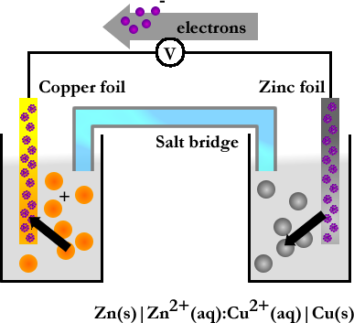
Daniell Cell (right) is type of galvanic or electrochemical cell, in which electrical work is done by the system. There is a potential difference E⁰, which is related to the Gibbs-energy of the reaction. Under standard conditions (see p194):
${ΔG}^{0}=−{\text{zFE}}^{0_{\text{cell}}}=\text{RT}\text{ln}(K)$
With ΔG⁰ in J/mol, z= number of moles electrons / moles reaction, F = Faraday constant in C/mol, E⁰_{cell} in volts and R = gas constant and T = absolute temperature.
A cell reaction is favorable if E⁰_{cell} is positive, ΔG⁰ is negative, K>1. E⁰_{cell} can be determined, but E_{cell} is more convenient. E_{cell} can be found with the Nernst equation (see below), but also by using values of standard reduction potentials for half cells.
$E_{\text{cell}}=E^{0_{\text{cell}}}−\frac{\text{RT}}{\text{ZF}}\text{ln}(\frac{[X_{\text{reduced}}]}{[X_{\text{oxidized}}]})$ (Nernst)
The standard reduction potentials are related to the standard hydrogen electrode (defined to be E⁰ = 0V): a platinum wire immersed in a solution of H⁺ ions at 1mol/dm³ in equilibrium with H₂ at 1 bar pressure. Remember the convention about E⁰_{cell}:
$$E^{0_{\text{cell}}}=E^{0_{\text{reduction}}}−E^{0_{\text{oxidation}}}$$
E⁰ values can be deceptive, since ΔG⁰ also takes “z” in account, ΔG⁰ is more reliable in determining which reaction is more thermodynamically favorable.
In reaction where [H⁺] is involved, E can obviously be influenced by pH. The value of the standard electrode can also be re-calculated for other pHs. The reduction of H₂O to H₂ can compete with this process, as can the reduction of O₂ to H₂O. Also, complex formation can hinder the desired reaction, e.g. the Zn²⁺/Zn half reaction potential applies only to hydrated ions, not to possibly present [Zn(OH)₄]²⁻ complexes.

An example of a redox reaction

Mn(OH)₃(s) + e⁻ | ↔ | MN(OH)₂(s) + [OH⁻](aq) | E⁰_{[OH-=1]} = +0.18V
O₂(g) + 2H₂O(l) + 4e⁻ | ↔ | 4[OH⁻](aq) | E⁰_{[OH-=1]} = +0.40V
O₂(g) + 4H⁺(aq) + 4e⁻ | ↔ | 2H₂O(l) | E⁰ = +1.23V
Mn³⁺(aq)+e⁻ | ↔ | Mn²⁺(aq) | E⁰ = +1.54V

A reaction takes place between the most powerful redox couple (if one can be found), the reaction with the highest voltage is favored, and the reaction with the lowest voltage occurs backwards. In this example the reaction only occurs if OH⁻ is present in 1M concentration.

4x | Mn(OH)₃(s) + e⁻ | ↔ | MN(OH)₂(s) + [OH⁻](aq) | E⁰_{[OH-=1]} = +0.18V
 | O₂(g) + 2H₂O(l) + 4e⁻ | ↔ | 4[OH⁻](aq) | E⁰_{[OH-=1]} = +0.40V | +
 | 4MN(OH)₂(s) + 4[OH⁻](aq) + O₂(g) + 2H₂O(l) + 4e⁻ | ↔ | 4Mn(OH)₃(s) + 4e⁻ + 4[OH⁻](aq) | 0.40V – 0.18V = 0.22V

Thus:

4MN(OH)₂(s) + O₂(g) + 2H₂O(l) | ↔ | 4Mn(OH)₃(s) | 0.22V

ΔG⁰ = -(4· 96485 · 0.22) = -85kJ / mole reaction;
or -21kJ / mole Mn(OH)₂

Omitted: other methods for E⁰ determination (p195), overpotential (p195).

7.3: Complex formation and precipitation.
The ΔG⁰ of a reaction depends on the concentrations of the involved species, the concentration can of course also change during the reaction, e.g. by complex formation or precipitation.
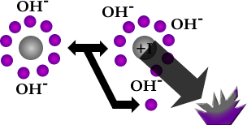
Metals in higher oxidation states are more stable with respect to reduction in alkaline solutions than in acidic solutions. This is because hydroxides (OH⁻) of metals in higher oxidation states precipitate in alkaline solutions (see also “An example of a redox reaction”), thus driving the reaction. This also applies for other ligands: higher oxidation states are more stabile, also when keeping the same number of ligands:

[Fe(CN)₆]³⁻(aq) + e⁻ → [Fe(CN)₆]⁴⁻(aq) E⁰=+0.36V

7.4: Disproportionation reactions.
Some redox reactions involve disproportionation reactions:

2Cu⁺(aq) ↔ Cu²⁺(aq) + Cu(s)
3[MnO₄]²⁻(aq) + 4H⁺(aq) ↔ 2[MnO₄]⁻(aq) + [MnO₂](s) + 2H₂O(l)

Can also be concluded from redox table, by combining the different redox reactions involving these species.

7.5: Potential diagrams.
To find out how species (e.g. [MnO₄]⁻ vs MnO₂(s)) are present in solutions, one can look at the different E⁰ values of the involved half reactions. These data can be represented as potential diagrams, also known as Latimer diagrams, or via Frost-Ebsworth diagrams (see next section).
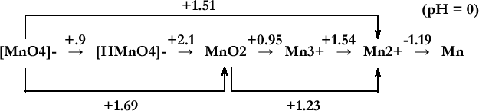
In the Latimer diagram species are placed from left to right in order of decreasing oxidation state, and E⁰ values are displayed. These E⁰ values should be calculated from the half-reactions using ΔG⁰ to account for the differences in numbers of electrons.

7.6: Frost-Ebsworth diagrams.
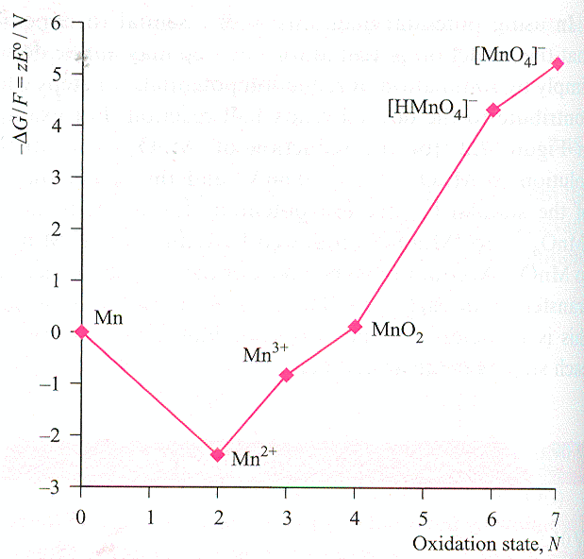
Frost-Ebsworth diagrams are a graphical representation of the stability of different oxidation states. -ΔG⁰ or -ΔG⁰/F values are plotted against N (the oxidation state). Bear in mind that -ΔG⁰/F = zE⁰. A Frost-Ebsworth diagram can be constructed from the matching Latimer diagram, this is done by step-by-step calculation of the next value, with the first set at 0, e.g. E⁰ for Mn to Mn²⁺ is -2.38V, and from Mn²⁺ to Mn³⁺ the E⁰ is 1.54V: -ΔG⁰/F = zE⁰ = 1 · 1.54, and -2.38 + 1.54 = -0.84 → Mn³⁺ = -0.84V.
Some conclusions that can be drawn from the diagram:
- The lowest point in the diagram represents the most (thermodynamically) stabile state.
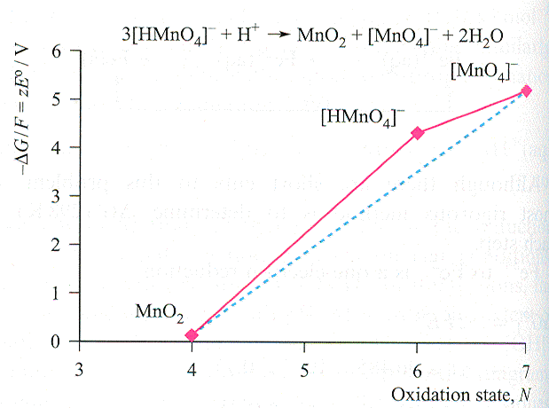
- Species towards the top-right of the diagram are strong oxidizers.
- Contrary to Latimer diagrams, values here can be added.
- In Housecroft Frost-Ebsworth diagrams going from left to right represents oxidation, and the accompanying E⁰ can be calculated. E.g.: Mn(s) ↔ Mn²⁺(aq) + 2e⁻, thus E⁰ = E⁰_{red} – E⁰_{ox} = zE⁰/z = -(-2.38/2) = 1.19V.
- “Convex points” are points that lie above a line drawn between neighboring points, species on these points are unstable with respect to the neighboring species, and will thus disproportionate (see reaction figure).
- Conversely, “concave points” (that lie below this line), are stabile with respect to disproportionation.
7.7: Standard reduction potentials and other quantities.
Omitted: factors influencing the magnitudes of standard potentials, thermodynamic data, values of Δ_{f}G⁰

7.8: Redox reactions in the extraction of elements from their ore.
Omitted: Earth is oxidizing environment, Ellingham diagrams.

